**ASSESSMENT NO. 2: DATA VISUALIZATION USING COMPLEX CHARTS (SPATIAL MAP AND WATERFALL CHART)**

For this assessment, please open the *Superstore* dataset in Tableau and perform the following:

1. **Spatial Map**

* Generate a spatial map of sales and profit in Central region from 2021 to 2024
* Your final output shall show only one spatial map with filters
* **Please post the screenshot of it below**

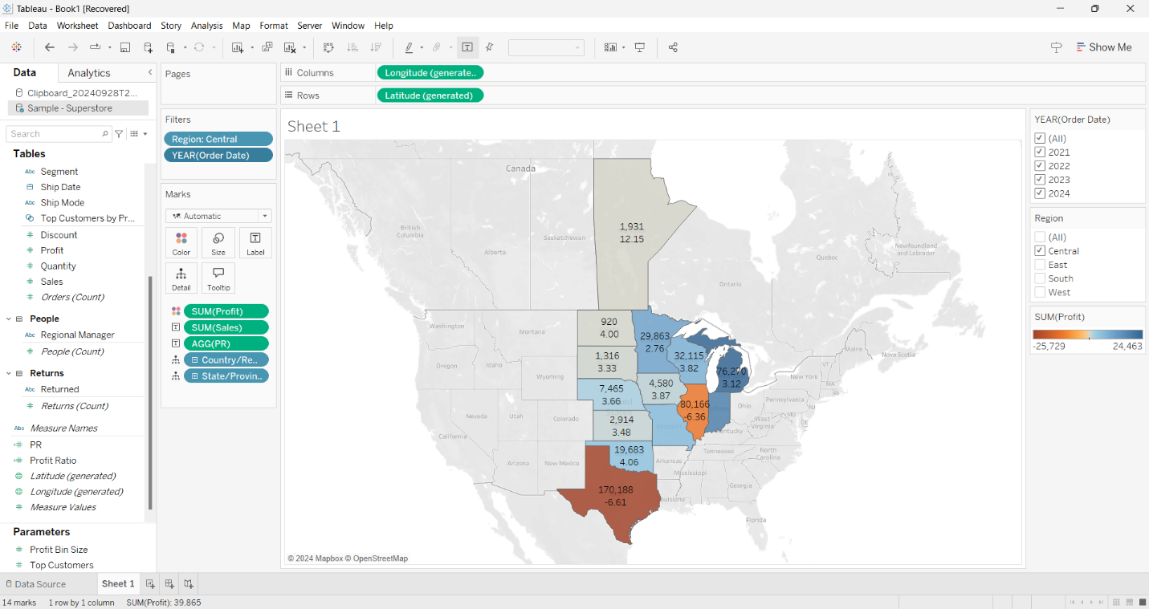

1. **Based on the spatial map, please fill in the following details**

**Sales and Profit in Central Region from 2021 to 2024**

|  |  |  |  |
| --- | --- | --- | --- |
| **Year** | **Sales** | **Profit** | **Profit Ratio** |
| 2021 | **103,838** | **540** | **30** |
| 2022 | **102,874** | **11,717** | **-3** |
| 2023 | **148,605** | **20,037** | **24** |
| 2024 | **147,854** | **7,572** | **65** |

1. **What are the states in the Central region recorded for the lowest profit ratio?**

**Answer:** *Texas (-7) and Illinois (-12)*

1. **Waterfall Chart**

* Generate a waterfall chart of sales and profit in Central region from 2021 to 2024
* Your final output shall show only one waterfall chart showing only the sub-category of products that recorded losses by State/Province with filters

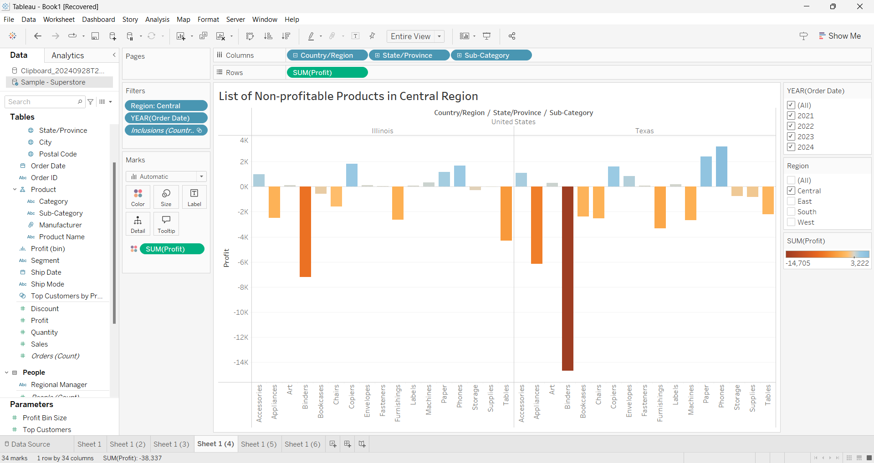

1. **Based on the waterfall chart, please fill in the following details**

**State/Province:** *Texas*

**Non-Profitable Products in Central Region from 2021 to 2024**

|  |  |  |  |  |  |  |
| --- | --- | --- | --- | --- | --- | --- |
| **Year** | **Product 1** | **Product 2** | **Product 3** | **Product 4** | **Product 5** | **Product 6** |
| 2021 | **Binders** | **Machine** | **Appliances** | **Chairs** | **Tables** | **Furnishings** |
| 2022 | **Appliances** | **Binders** | **Bookcases** | **Chairs** | **Tables** | **Furnishings** |
| 2023 | **Binders** | **Furnishings** | **Bookcases** | **Chairs** | **Appliances** | **Supplies** |
| 2024 | **Binders** | **Appliances** | **Furnishings** | **Tables** | **Bookcases** | **Chairs** |

**State/Province:** *Illinois*

**Non-Profitable Products in Central Region from 2021 to 2024**

|  |  |  |  |  |  |  |
| --- | --- | --- | --- | --- | --- | --- |
| **Year** | **Product 1** | **Product 2** | **Product 3** | **Product 4** | **Product 5** | **Product 6** |
| 2021 | **Tables** | **Binders** | **Appliances** | **Chairs** | **Furnishings** | **Storage** |
| 2022 | **Appliances** | **Furnishings** | **Tables** | **Chairs** | **Bookcases** | **Binders** |
| 2023 | **Furnishings** | **Tables** | **Binders** | **Appliances** | **Chairs** | **Bookcases** |
| 2024 | **Binders** | **Tables** | **Furnishings** | **Chairs** | **Appliances** | **Bookcases** |

